Identify the classes. Classify them as weak and strong classes and draw the class diagram for the specified Case Study

Table of Contents

Classes 2

User 2

Attributes 2

Methods 2

Expense 2

Attributes: 2

Methods: 2

Dashboard 2

Attributes: 2

Methods: 2

Settings 2

Attributes: 2

Methods: 2

AuthenticationManager 2

Methods: 2

Class Relationships 2

Class Diagram 3

# Classes

## User

Attributes: UserID, Username, Password, Email, BudgetLimit

Methods: Login (), SignUp (), ChangePassword (), SetBudgetLimit ()

## Expense

Attributes: ExpenseID, UserID, Amount, Category, Description, Date

Methods: AddExpense (), ViewExpenseReport (), CategorizeExpense ()

## Dashboard

Attributes: UserID, Expense Data

Methods: Generate Dashboard ()

## Settings

Attributes: UserID, Theme, NotificationPreferences

Methods: ChangeTheme (), UpdateNotificationPreferences ()

# AuthenticationManager

Methods: Verify Login (), Verify Signup (), GenerateOTP (), ResetPassword ()

# Class Relationships

User has a Dashboard.

User can have multiple Expenses.

Settings are associated with a User.

Authentication Manager manages User authentication processes.

Weak and Strong Classes

Strong Classes: User, Expense, Dashboard, Settings

These classes have distinct attributes and methods, representing clear entities within the system.

Weak Class: Authentication Manager

This class is more of a manager or service class, handling specific processes rather than representing a distinct entity with attributes.

# Class Diagram

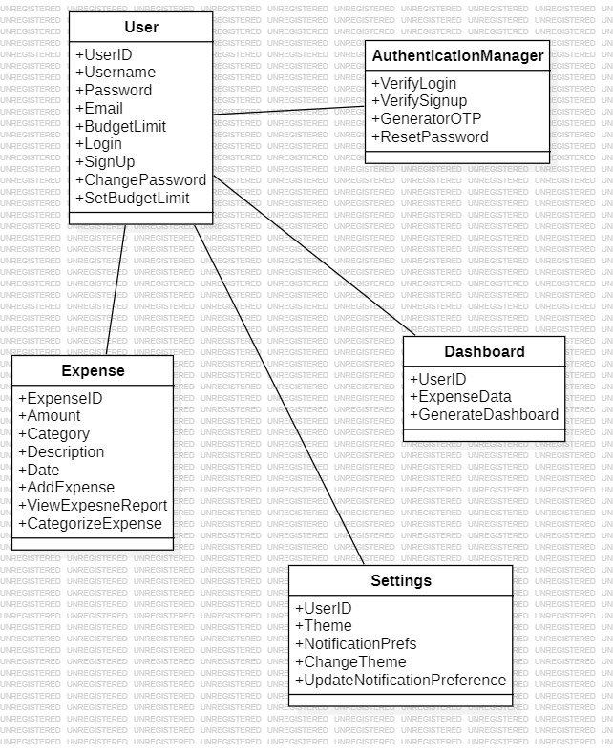

Figure 1:Expense Sharing App Class Diagram